
VISVESVARAYA TECHNOLOGICAL UNIVERSITY

BELAGAVI – 590018, Karnataka INTERNSHIP REPORT

ON

“PHOTOGRAPHY WEBSITE”
Submitted in partial fulfilment for the award of degree(18CSI85)

BACHELOR OF ENGINEERING IN

COMPUTER SCIENCE AND ENGINEERING
Submitted by:
TRIPURANENI CHANDRIKA
1KG19CS107


Conducted at
VARCONS TECHNOLOGIES PVT. LTD



K.S. SCHOOL OF ENGINEERING AND MANAGEMENT
Department of Computer Science and Engineering
No. 15, Mallasandra, off Kanakapura Road, Bengaluru-560109

K.S. SCHOOL OF ENGINEERING AND MANAGEMENT
Department of Computer science and Engineering
No. 15, Mallasandra, off Kanakapura Road, Bengaluru-560109



CERTIFICATE

This is to certify that the Internship titled “Photography website” carried out by Ms.TRIPURANENI CHANDRIKA, a bonafide student of K.S. School of Engineering and Management , in partial fulfillment for the award of Bachelor of Engineering, in COMPUTER SCIENCE under Visvesvaraya Technological University, Belagavi, during the year 2022-2023. It is certified that all corrections/suggestions indicated have been incorporated in the report.

The project report has been approved as it satisfies the academic requirements in respect of Internship prescribed for the course Internship / Professional Practice (18CSI85)

Signature of Guide Signature of HOD Signature of Principal

External Viva:

Name of the Examiner Signature with Date

1)

2)

DECLARATION

I, Tripuraneni Chandrika, final year student of Branch, Computer Science and Engineering, College Name – KS School of Engineering and Management, 560 082, declare that the Internship has been successfully completed, in VARCONS TECHNOLOGIES PVT.LTD. This report is submitted in partial fulfillment of the requirements for award of Bachelor Degree in Computer Science and Engineering, during the academic year 2022-2023.

Date: :
Place: Bangalore
USN: 1KG19CS107
NAME: TRIPURANENI CHANDRIKA

OFFER LETTER PROVIDED BY THE COMPANY

ACKNOWLEDGEMENT

This Internship is a result of accumulated guidance, direction and support of several important persons. We take this opportunity to express our gratitude to all who have helped us to complete the Internship.

We express our sincere thanks to our principal, for providing us adequate facilities to undertake this Internship.

We would like to thank our Head of Dept – branch code, for providing us an opportunity to carry out Internship and for his valuable guidance and support.

We would like to thank our (Lab assistant name) Software Services for guiding us during the period of internship.

We express our deep and profound gratitude to our guide, Guide name, Assistant/Associate Prof, for her keen interest and encouragement at every step in completing the Internship.

We would like to thank all the faculty members of our department for the support extended during the course of Internship.

We would like to thank the non-teaching members of our dept, for helping us during the Internship.

Last but not the least, we would like to thank our parents and friends without whose constant help, the completion of Internship would have not been possible.

TRIPURANENI CHANDRIKA
1KG19CS107

ABSTRACT

Photography is the art, application, and practice of creating durable images by recording light, either electronically by means of an image sensor, or chemically by means of a light-sensitive material such as photographic film. This Photography website includes the great monuments, popular places, heritage rich sites of India. The Gallery comprises breathtaking views or pictures of various historical places, monuments, culture, heritage rich sites. This site is user-friendly and provides a download option to get the images user liked. This website involves the documentation of an area's landscape, people, cultures, customs, and history. The purpose of the Photography website is to provide user-friendly and fulfill the requirements of the users so that data/information can be accessed easily without any manipulation.

Table of Contents

Sl no | Description | Page no
1 | Company Profile | 8
2 | About the Company | 9
3 | Introduction | 13-14
4 | System Analysis | 15
5 | Requirement Analysis | 15
6 | Design Analysis | 15
7 | Implementation | 25
8 | Snapshots | 26-29
9 | Conclusion | 32
10 | References | 33

CHAPTER 1

COMPANY PROFILE

A Brief History of Varcons Technologies
Varcons Technologies, was incorporated with a goal” To provide high quality and optimal Technological Solutions to business requirements of our clients”. Every business is a different and has a unique business model and so are the technological requirements. They understand this and hence the solutions provided to these requirements are different as well. They focus on clients requirements and provide them with tailor made technological solutions. They also understand that Reach of their Product to its targeted market or the automation of the existing process into e-client and simple process are the key features that our clients desire from Technological Solution they are looking for and these are the features that we focus on while designing the solutions for their clients.
Sarvamoola Software Services. is a Technology Organization providing solutions for all web design and development, MYSQL, PYTHON Programming, HTML, CSS, ASP.NET and LINQ. Meeting the ever-increasing automation requirements, Sarvamoola Software Services. specialize in ERP, Connectivity, SEO Services, Conference Management, effective web promotion and tailor-made software products, designing solutions best suiting clients requirements.
Varcons Technologies, strive to be the front runner in creativity and innovation in software development through their well-researched expertise and establish it as an out of the box software development company in Bangalore, India. As a software development company, they translate this software development expertise into value for their customers through their professional solutions.
They understand that the best desired output can be achieved only by understanding the clients demand better. Varcons Technologies work with their clients and help them to define their exact solution requirement. Sometimes even they wonder that they have completely redefined their solution or new application requirement during the brainstorming session, and here they position themselves as an IT solutions consulting group comprising of high caliber consultants.
They believe that Technology when used properly can help any business to scale and achieve new heights of success. It helps Improve its efficiency, profitability, reliability; to put it in one
sentence” Technology helps you to Delight your customers” and that is what we want to achieve.

CHAPTER 2 ABOUT THE COMPANY
Varcons Technologies is a Technology Organization providing solutions for all web design and development, MYSQL, PYTHON Programming, HTML, CSS, ASP.NET and LINQ. Meeting the ever-increasing automation requirements, Varcons Technologies specialize in ERP, Connectivity, SEO Services, Conference Management, effective web promotion and tailor-made software products, designing solutions best suiting clients requirements. The organization where they have a right mix of professionals as a stakeholders to help us serve our clients with best of our capability and with at par industry standards. They have young, enthusiastic, passionate and creative Professionals to develop technological innovations in the field of Mobile technologies, Web applications as well as Business and Enterprise solution. Motto of our organization is to “Collaborate with our clients to provide them with best Technological solution hence creating Good Present and Better Future for our client which will bring a cascading a positive effect in their business shape as well”. Providing a Complete suite of technical solutions is not just our tag line, it is Our Vision for Our Clients and for Us, we strive hard to achieve it.

Products of Varcons Technologies.
Android Apps

It is the process by which new applications are created for devices running the Android operating system. Applications are usually developed in Java (and/or Kotlin; or other such option) programming language using the Android software development kit (SDK), but other development environments are also available, some such as Kotlin support the exact same Android APIs (and bytecode), while others such as Go have restricted API access.
The Android software development kit includes a comprehensive set of development tools. These include a debugger, libraries, a handset emulator based on QEMU, documentation, sample code, and tutorials. Currently supported development platforms include computers

running Linux (any modern desktop Linux distribution), Mac OS X 10.5.8 or later, and Windows 7 or later. As of March 2015, the SDK is not available on Android itself, but software development is possible by using specialized Android applications.
Web Application

It is a client–server computer program in which the client (including
client- side logic) runs in a web browser. Common web applications include web mail, online
retail sales, online auctions, wikis, instant messaging services and many other functions. Web
applications use web documents written in a standard format such as HTML and JavaScript, which are supported by a variety of web browsers. Web applications can be considered as a specific variant of client–server software where the client software is downloaded to the client machine when visiting the relevant web page, using standard procedures such as HTTP. The Client web software updates may happen each time the web page is visited. During the session, the web browser interprets and displays the pages, and acts as the universal client for any web application. The use of web application frameworks can often reduce the number of errors in a program, both by making the code simpler, and by allowing one team to concentrate on the framework while another focuses on a specified use case. In applications which are exposed to constant hacking attempts on the Internet, security- related problems can be caused by errors in the program.
Frameworks can also promote the use of best practices such as GET after POST. There are some who view a web application as a two-tier architecture. This can be a “smart” client that performs all the work and queries a “dumb” server, or a “dumb” client that relies on a “smart” server. The client would handle the presentation tier, the server would have the database (storage tier), and the business logic (application tier) would be on one of them or on both. While this increases the scalability of the applications and separates the display and the database, it still doesn’t allow for true specialization of layers, so most applications will outgrow this model. An emerging strategy for application software companies is to provide web access to software previously distributed as local applications. Depending on the type of application, it may require the development of an entirely different browser-based interface, or merely adapting an existing application to use different presentation technology. These programs allow the user to pay a monthly or yearly fee for use of a software application without having to install it on a local hard drive. A company which follows this strategy is known as an application service provider (ASP), and ASPs are currently receiving much attention in the software industry.
Security breaches on these kinds of applications are a major concern because it can involve both enterprise information and private customer data. Protecting these assets is an important part of any web application and there are some key operational areas that must be included in

the development processes. This includes processes for authentication, authorization, asset handling, input, and logging and auditing. Building security into the applications from the beginning can be more effective and less disruptive in the long run.
Web design

It is encompassing many different skills and disciplines in the production and maintenance of websites. The different areas of web design include web graphic design; interface design; authoring, including standardized code and proprietary software; user experience design; and
search engine optimization. The term web design is normally used to describe the design
process relating to the front-end (client side) design of a website including writing mark up. Web design partially overlaps web engineering in the broader scope of web development. Web designers are expected to have an awareness of usability and if their role involves creating mark up then they are also expected to be up to date with web accessibility guidelines. Web design partially overlaps web engineering in the broader scope of web development.

Departments and services offered
Varcons Technologies plays an essential role as an institute, the level of education, development of student’s skills are based on their trainers. If you do not have a good mentor then you may lag in many things from others and that is why we at Varcons Technologies gives you the facility of skilled employees so that you do not feel unsecured about the academics. Personality development and academic status are some of those things which lie on mentor’s hands. If you are trained well then you can do well in your future and knowing its importance of Varcons Technologies always tries to give you the best.
They have a great team of skilled mentors who are always ready to direct their trainees in the best possible way they can and to ensure the skills of mentors we held many skills development programs as well so that each and every mentor can develop their own skills with the demands of the companies so that they can prepare a complete packaged trainee.

Services provided by Varcons Technologies.
- Core Java and Advanced Java

- Web services and development

- Dot Net Framework

- Python

- Selenium Testing

- Conference / Event Management Service

- Academic Project Guidance

- On The Job Training

- Software Training

CHAPTER 3 INTRODUCTION

Introduction to Web Apps
Web applications are similar to the traditional applications you’d install on your Information, such as Microsoft Office. They are able to perform the same kinds of tasks, they look the same and they feel the same but there is one key difference - the application itself is not installed on your phone or Information, but lives in the cloud. Web apps are not new, but it used to be that they were often unable to compete with more traditional applications for business-critical functions or where rich user interaction was required. This is no longer the case. With the power of modern web technologies, we are able to design and build performing, secure, and feature rich applications that live in the cloud and bring with them a huge number of benefits.

They can be accessed from anywhere.

- Because web applications are built with web technologies and they run in a web browser Internet Explorer, Google Chrome, Mozilla Firefox – this allows them to be accessed from every web enabled tool. As long as you have an internet connection you can use them.
- It allows for remote working, it allows for rapid publishing of content, it allows for real time collaboration between teams. If you have web access, you have the ability to access your business tools.

They are cost effective.

- Web applications are cheaper to produce and maintain than traditional applications. No matter how many platforms your business uses (Mac, Linux, Windows) web application build can be used across them all.

They benefit from more rapid update cycles.

- A huge benefit of web applications is that when an update is released, all of your users are immediately using that version. This doesn’t happen with installed applications, especially in large organizations with IT policies that restrict administrator access.

They are secure.

- Web developers have had to become experts in security – the web is a platform designed

- They also benefit from the ability to launch updates in real-time – the application on the servers is the application people are using. The applications on people’s laptops however is the version last installed. And when those laptops get left on a train it’s not a concern, as nothing is stored locally.

They enable more computing with fewer Information.

- Web applications push all of the hard work to the servers, and act as intermediaries between the user interface and the calculations happening behind the scenes. This means you can accomplish terrifyingly complex work on a tablet, or your phone.
- We’ve built web applications that allow people to understand the complex relationships between 250,000 pieces of art on their phones, and applications that run the business systems of one of the largest solar energy providers in the world. Often these products are not financially viable to build using traditional application processes.

Problem Statement
Develop an application which facilitates creation of web pages having a need to install any HTML editor-based software and also which can be used by any novice user (no HTML knowledge needed) that is developing web pages on the online. This module is designed to reduce the process involved in managing the activity of customers and business where the business can sell their services and the customers can buy those.

Introduction to B2C Ecommerce Website Development with Admin Panel

B2C E-commerce website content providers to focus on creating effective assessment questions and focusing on providing a platform for easy access between Buyer and Consumer.
Here we present techniques that are pertinent to the elements of assessment process: answers submission, Informationized grading, and feedback after submission. As the modern organizations are automated and Information’s are working as per the instructions, it becomes essential for the coordination of human beings, commodity and Information’s in a modern organization.

CHAPTER 4

SYSTEM ANALYSIS
System analysis is the way of studying a system with an eye on solving its problem using computer. It is the most essential part of the development of a project of a system analysis. System analysis consists of system element, process and technology. To analyze a system, has to study the systems in detail.
The analyst has to understand the functioning and concepts of the system in detail, before design the appropriate computer-based system that will meet all the requirements of the existing system. The system analyst has to carry out a customary approach to use the computer for problem solving.

Existing System

Requirement Collection:

Front End requirements are a list of necessary functions, capabilities or characteristics related to WordPress theme and plans for creating it. The process that was held while collecting the requirements of the system are as follows:

Team Discussion.

Team Discussion is the process of discussing how the project should be implemented by the professionals.

Understanding the focused group.

Theme should have the aim of what the audience want to see in the future.

Proposed System

Functional Requirements

Functional requirement of the system describes what the system does. The main functional requirements of this system are as follows:

User should be able to view all the necessary information and specification about this project.

Browser compatibility.

Responsive to all devices.

Administrator can modify the theme under GPL License.

Non-Functional Requirements

A non-functional requirement describes how the system performs a certain function. Non-functional requirements generally specify the system’s quality attributes or characteristics. Puranobooks follows properties such as reliability, usability, storage occupancy, performance, and response time.

System Requirement Specification

Should describe functional and non-functional requirements so that they are understandable by system users who don’t have detailed technical knowledge.

User requirements are defined using natural language, tables and diagrams. Software Requirements Specification.

Scripting Languages: HTML, JavaScript.

Styling Languages: CSS.

Server-side language:php.

IDE: Visual Studio, Xampp, Hardware Requirements Specification.

Processor: Intel core i3 or i5.

Hard Disk: 250 GB.

Ram: 2GB.

Objective of the System

The main objectives of the system are:

Provide the great scenaric places of the particular city the user require.

Best pictures of the heritage rich sites, famous places in the city.

Most popular places for the tourists to visit.

Website should also provide the download option, to download the high-definition pictures for free of cost.

Provide feedback to the developers of the site.

CHAPTER5

REQUIREMENT ANALYSIS

Hardware Requirement Specification
  - MySQL

  - NODE JS

  - Notepad++ Editor

  - Processor: Intel core i5 processer

  - Memory: 15.6 GB

  - Hard Disk: 40 GB

Software Requirement Specification

Functional Requirements

First of all, requirements of this system are analyzed. After investigation and analysis of related websites, we confirm that the system should consist of photography management subsystem, which play different roles, but are closed related with each other:

Security
  - . Usability
  - . Speed and Reliability
  - Simplicity

Non-Functional Requirements

Availability

The online registration system shall permit backing up of the registration database while other registration actives are going on.

Accessibility

The system shall be accessible by people with specific vision needs to the extent that a user shall be able to display whole user interface in a larger font without truncating displayed text or other values.

Security

The access permissions for system data may only be change by the systems data administrator passwords shall never be viewable at the point of entry or any other time.

CHAPTER 6 DESIGN ANALYSIS
Index.php

<!DOCTYPE html>
<html>
<head>
<title> Example</title>
<meta charset="utf-8">
<meta name="viewport" content="width=device-width, initial-scale=1">
<link rel="stylesheet" type="text/css" href="css/style.css">
<link rel="stylesheet" href="https://cdn.jsdelivr.net/npm/bootstrap@4.6.1/dist/css/bootstrap.min.css">
<link href="https://fonts.googleapis.com/css?family=Josefin+Sans&display=swap" rel="stylesheet">
</head>
<body>
<nav class="navbar navbar-expand-lg bg-dark">
<div class="container-fluid">
<a class="navbar-brand" href="#">TEAM ALPHA</a>
<button class="navbar-toggler" type="button" data-bs-toggle="collapse" data-bs-target="#navbarSupportedContent" aria-controls="navbarSupportedContent" aria-expanded="false" aria-label="Toggle navigation">
<span class="navbar-toggler-icon"></span>
</button>
<div class="collapse navbar-collapse" id="navbarSupportedContent">
<ul class="navbar-nav ml-auto mb-2 mb-lg-0">
<li class="nav-item">
<a class="nav-link active" aria-current="page" href="index.php">Home</a>
</li>
<li class="nav-item">
<a class="nav-link" href="#">About</a>
</li>
<li class="nav-item">
<a class="nav-link" href="#">Services</a>
</li>
<li class="nav-item">
<a class="nav-link" href="#">Gallery</a>
</li>
<li class="nav-item">
<a class="nav-link" href="#">Contact</a>
</li>
</ul>
</div>
</div>
</nav>
<div id="demo" class="carousel slide" data-ride="carousel">
<ul class="carousel-indicators">
<li data-target="#demo" data-slide-to="0" class="active"></li>
<li data-target="#demo" data-slide-to="1"></li>
<li data-target="#demo" data-slide-to="2"></li>
</ul>
<div class="carousel-inner">
<div class="carousel-item active">
<img src="img\ban1.jpeg" alt="Bangalore" width="1100" height="500">
<div class="carousel-caption">
<h3>Bangalore</h3>
<p>We love the Beautiful Climate!</p>
</div>
</div>
<div class="carousel-item">
<img src="img\rr1.jpg" alt="New Delhi" width="1100" height="500">
<div class="carousel-caption">
<h3>New Delhi</h3>
<p>We had such a great time in ND!</p>
</div>
</div>
<div class="carousel-item">
<img src="img\rr3.jpg" alt="Varanasi" width="1100" height="500">
<div class="carousel-caption">
<h3>Varanasi</h3>
<p>Thank you, Varanasi!</p>
</div>
</div>
</div>
<a class="carousel-control-prev" href="#demo" data-slide="prev">
<span class="carousel-control-prev-icon"></span>
</a>
<a class="carousel-control-next" href="#demo" data-slide="next">
<span class="carousel-control-next-icon"></span>
</a>
</div>
<section class="my-5">
<div class="py-5">
<h2 class="text-center">About Us</h2>
</div>
<div class="container-fluid">
<div class="row">
<div class="col-lg-6 col-md-6 col-12">
<img src="img/hh1.jpg" class="img-fluid aboutimg1">
</div>
<div class="col-lg-6 col-md-6 col-12">
<h2 class="display-4"> I am Team Alpha.</h2>
<p class="py-3"> This photography website includes great high-definition, pictures of the popular cities in India. The gallery comprises breath-taking views of various historical monuments, heritage rich sites. This site is user-friendly and provided a download option to get the images. Hope you find this website helpful.
</p>
</div>

</div>
</div>
</section>
<section class="my-5">
<div class="py-5">
<h2 class="text-centre">Our Services</h2>
</div>
<div class="container-fluid">
<div class="row">
<div class="col-lg-4 col-md-4 col-12">
<div class="card">
<img class="card-img-top aboutimg" src="img/p1.jpg" alt="Card image">
<div class="card-body">
<h4 class="card-title">Bangalore:)</h4>
<p class="card-text">Silicon City!.</p>
<a href="profile1.php" class="btn btn-primary">See Profile</a>
</div>
</div>
</div>
<div class="col-lg-4 col-md-4 col-12">
<div class="card">
<img class="card-img-top aboutimg" src="img/pp2.jpg" alt="Card image">
<div class="card-body">
<h4 class="card-title">Telangana:)</h4>
<p class="card-text">High-tech City!.</p>
<a href="profile2.php" class="btn btn-primary">See Profile</a>
</div>
</div>
</div>
<div class="col-lg-4 col-md-4 col-12">
<div class="card">
<img class="card-img-top aboutimg" src="img/pp3.jpg" alt="Card image">
<div class="card-body">
<h4 class="card-title">New Delhi:)</h4>
<p class="card-text">Capital City.</p>
<a href="profile3.php" class="btn btn-primary">See Profile</a>
</div>
</div>
</div>
</div>
</div>
</section>

<section class="my-5">
<div class="py-5">
<h2 class="text-center">Our Gallery</h2>
</div>
<div class="container-fluid">
<div class="row">
<div class="col-lg-4 col-md-4 col-12">
<img src="img/gg1.jpg" class="img-fluid aboutimg py-5">
<a href="img/gg1.jpg" download class="download-btn">Download</a>
</div>
<div class="col-lg-4 col-md-4 col-12">
<img src="img/gg2.jpg" class="img-fluid aboutimg py-5">
<a href="img/gg2.jpg" download class="download-btn">Download</a>
</div>
<div class="col-lg-4 col-md-4 col-12">
<img src="img/gg3.jpg" class="img-fluid aboutimg py-5">
<a href="img/gg3.jpg" download class="download-btn">Download</a>
</div>
<div class="col-lg-4 col-md-4 col-12">
<img src="img/gg4.jpg" class="img-fluid aboutimg py-5">
<a href="img/gg4.jpg" download class="download-btn">Download</a>
</div>
<div class="col-lg-4 col-md-4 col-12">
<img src="img/gg5.jpg" class="img-fluid aboutimg py-5">
<a href="img/gg5.jpg" download class="download-btn">Download</a>
</div>
<div class="col-lg-4 col-md-4 col-12">
<img src="img/gg6.jpg" class="img-fluid aboutimg py-5">
<a href="img/gg6.jpg" download class="download-btn">Download</a>
</div>
<div class="col-lg-4 col-md-4 col-12">
<img src="img/gg7.jpg" class="img-fluid aboutimg py-5">
<a href="img/gg7.jpg" download class="download-btn">Download</a>
</div>
<div class="col-lg-4 col-md-4 col-12">
<img src="img/gg8.jpg" class="img-fluid aboutimg py-5">
<a href="img/gg8.jpg" download class="download-btn">Download</a>
</div>
<div class="col-lg-4 col-md-4 col-12">
<img src="img/gg9.jpg" class="img-fluid aboutimg py-5">
<a href="img/gg9.jpg" download class="download-btn">Download</a>
</div>
</div>
</div>

</section>

<section class="my-5">
<div class="py-5">
<h2 class="text-center">Contact Us</h2>
</div>
<div class="w-50 m-auto">
<form action="userinfo.php" method="post">
<div class="form-group">
<label>Username</label>
<input type="text" name="user" autocomplete="off" class="form-control">
</div>
<div class="form-group">
<label>Email Id</label>
<input type="text" name="email" autocomplete="off" class="form-control">
</div>
<div class="form-group">
<label>Mobile </label>
<input type="text" name="mobile" autocomplete="off" class="form-control">
</div>
<div class="form-group">
<label>Comments</label>
<textarea class="form-control" name="comment"></textarea>
</div>
<button type="submit" class="btn btn-success">Submit</button>
</form>
</div>

</section>

<footer>
<p class="p-3 bg-dark text-white text-center">@teamalphaproduction</p>
</footer>

<script src="https://cdn.jsdelivr.net/npm/jquery@3.6.0/dist/jquery.slim.min.js"></script>
<script src="https://cdn.jsdelivr.net/npm/popper.js@1.16.1/dist/umd/popper.min.js"></script>
<script src="https://cdn.jsdelivr.net/npm/bootstrap@4.6.1/dist/js/bootstrap.bundle.min.js"></script>

</body>
</html>

Style.css

*{
margin: 0;
padding: 0;
box-sizing: border-box;
font-family: 'Josefin Sans',sans-serif;
}

.carousel-inner img {
width: 100%;
height: 90vh!important;
}

.aboutimg1{
width: 100%;
height: 250px!important;
}
.aboutimg{
width: 100%;
height: 350px!important;
}

.aboutimage{
width: 100%;
height: 100%!important;
}
.download-btn{
background-color: dark blue;
border: none;
color: white;
padding: 12px 30px;
font-size: 20px;
border-radius: 5px;
}
.download-btn: hover{
background-color: royal blue;
}

About.php

<!DOCTYPE html>
<html>
<head>
<title> Example</title>
<meta charset="utf-8">
<meta name="viewport" content="width=device-width, initial-scale=1">
<link rel="stylesheet" type="text/css" href="css/style.css">
<link rel="stylesheet" href="https://cdn.jsdelivr.net/npm/bootstrap@4.6.1/dist/css/bootstrap.min.css">
<link href="https://fonts.googleapis.com/css?family=Josefin+Sans&display=swap" rel="stylesheet">
</head>
<body>
<nav class="navbar navbar-expand-lg bg-dark">
<div class="container-fluid">
<a class="navbar-brand" href="#">Team Alpha</a>
<button class="navbar-toggler" type="button" data-bs-toggle="collapse" data-bs-target="#navbarSupportedContent" aria-controls="navbarSupportedContent" aria-expanded="false" aria-label="Toggle navigation">
<span class="navbar-toggler-icon"></span>
</button>
<div class="collapse navbar-collapse" id="navbarSupportedContent">
<ul class="navbar-nav ml-auto mb-2 mb-lg-0">
<li class="nav-item">
<a class="nav-link active" aria-current="page" href="index.php">Home</a>
</li>
<li class="nav-item">
<a class="nav-link" href="about.php">About</a>
</li>
<li class="nav-item">
<a class="nav-link" href="#">Services</a>
</li>
<li class="nav-item">
<a class="nav-link" href="#">Gallery</a>
</li>
<li class="nav-item">
<a class="nav-link" href="#">Contact</a>
</li>
</ul>
</div>
</div>
</nav>

<div class="jumbotron">
<h1>Team Alpha:)</h1>
<p>We The Web Developers,LIKE,SHARE & SUBSCRIBE</p>
</div>
<section class="my-5">
<div class="py-5">
<h2 class="text-centre">About Us</h2>
</div>
<div class="container-fluid">
<div class="row">
<div class="col-lg-6 col-md-6 col-12">
<img src="img/download.jpg" class="img-fluid aboutimg">
</div>
<div class="col-lg-6 col-md-6 col-12">
<h2 class="display-4"> I am Team Alpha.</h2>
<p class="py-3"> This photography website includes great high-definition, pictures of the popular cities in India. The gallery comprises breath-taking views of various historical monuments, heritage rich sites.This site is user-friendly and provided a download option to get the images. Hope you find this website helpful.

</p>
</div>

</div>
</div>
</section>
<footer>
<p class="p-3 bg-dark text-white text-centre">@teamalphaproduction</p>
</footer>

</body>
</html>

CHAPTER 7 IMPLEMENTATION

Implementation is the stage where the theoretical design is turned into a working system. The most crucial stage in achieving a new successful system and in giving confidence on the new system for the users that it will work efficiently and effectively.
The system can be implemented only after thorough testing is done and if it is found to work according to the specification. It involves careful planning, investigation of the current system and its constraints on implementation, design of methods to achieve the changeover and an evaluation of change over methods a part from planning.
Two major tasks of preparing the implementation are education and training of the users and testing of the system. The more complex the system being implemented, the more involved will be the system analysis and design effort required just for implementation.

The implementation phase comprises of several activities. The required hardware and software acquisition is carried out. The system may require some software to be developed. For this, programs are written and tested. The user then changes over to his new fully tested system and the old system is discontinued.

TESTING
The testing phase is an important part of software development. It is the Information zed system will help in automate process of finding errors and missing operations and also a complete verification to determine whether the objectives are met and the user requirements are satisfied. Software testing is carried out in three steps:
- The first includes unit testing, where in each module is tested to provide its correctness, validity and also determine any missing operations and to verify whether the objectives have been met. Errors are noted down and corrected immediately.
- Unit testing is the important and major part of the project. So, errors are rectified easily in particular module and program clarity is increased. In this project entire system is divided into several modules and is developed individually. So, unit testing is conducted to individual modules.
- The second step includes Integration testing. It need not be the case, the software whose modules when run individually and showing perfect results, will also show perfect results when run as a whole.

CHAPTER 8 SNAPSHOTS

8.1 Home Page
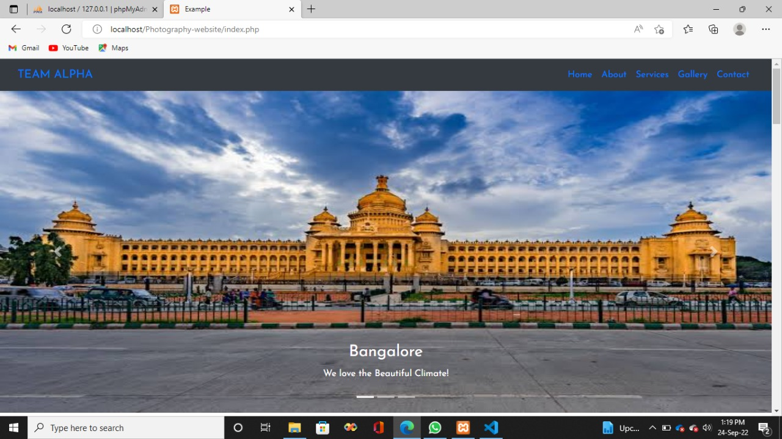
8.1.1 Bangalore City

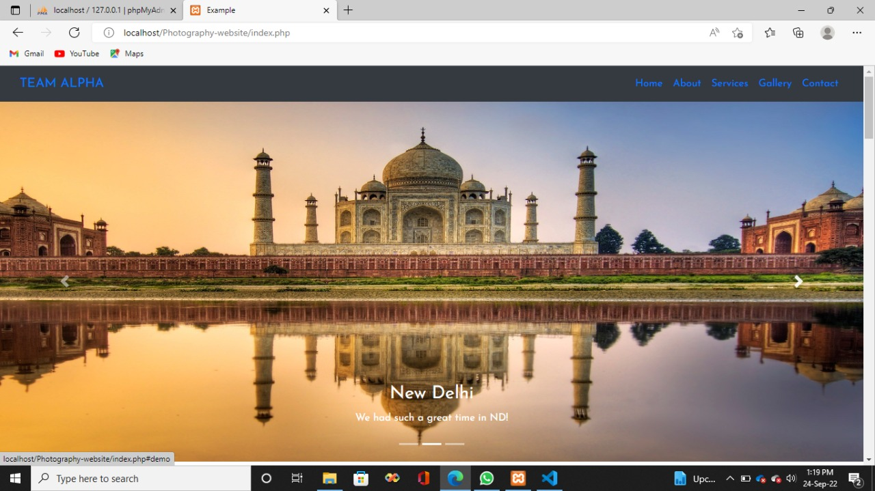
8.1.2 New Delhi City
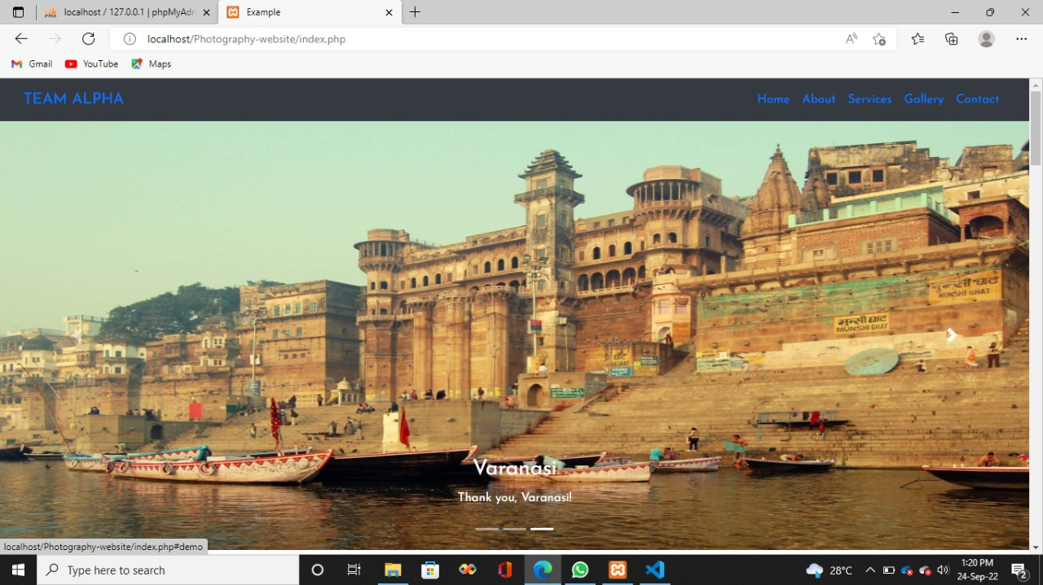

8.1.3 Varanasi City

8.2 About Us

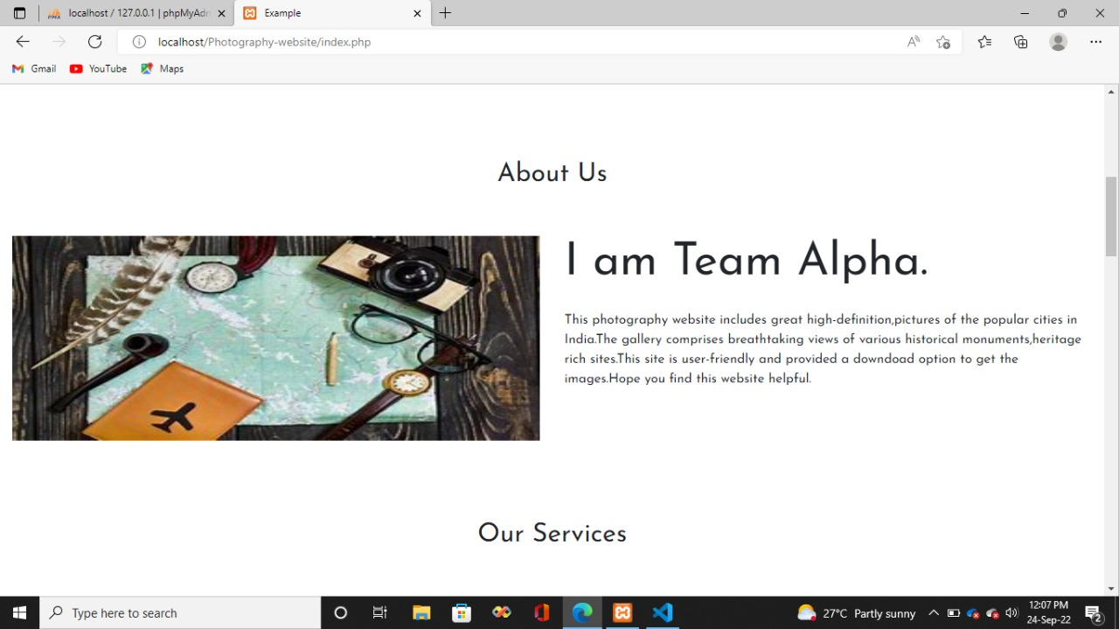

8.2.1 About TEAM ALPHA

8.3 Services

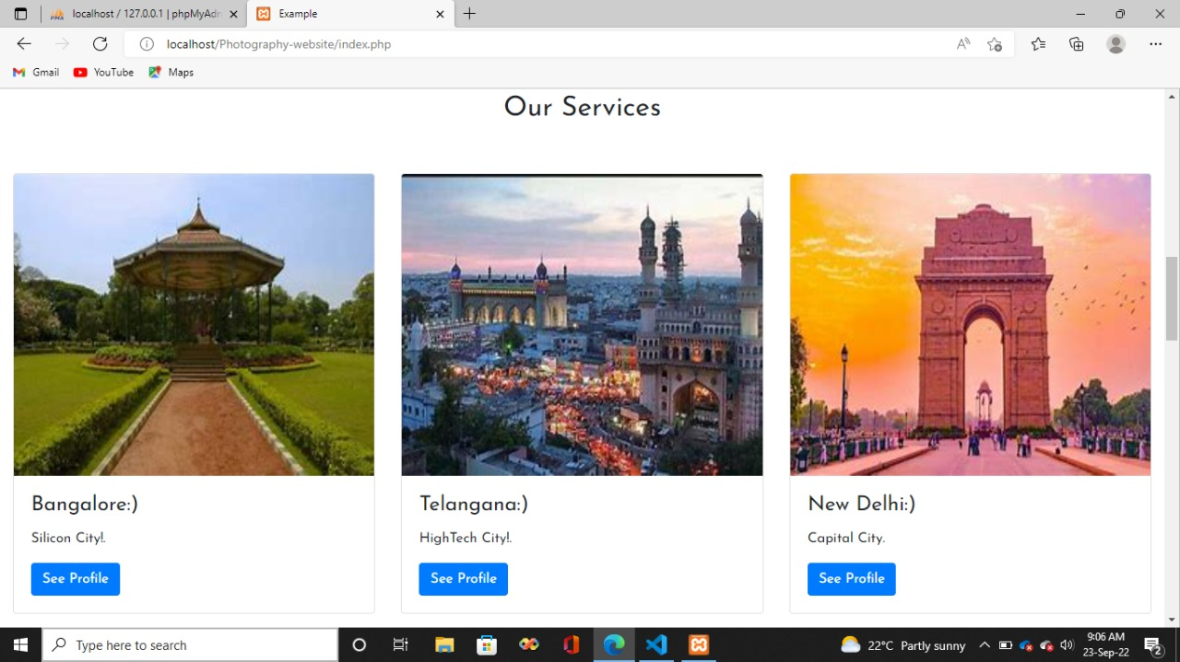

8.3.1 Services offered

8.4 Gallery

8.4.1 Bangalore Gallery

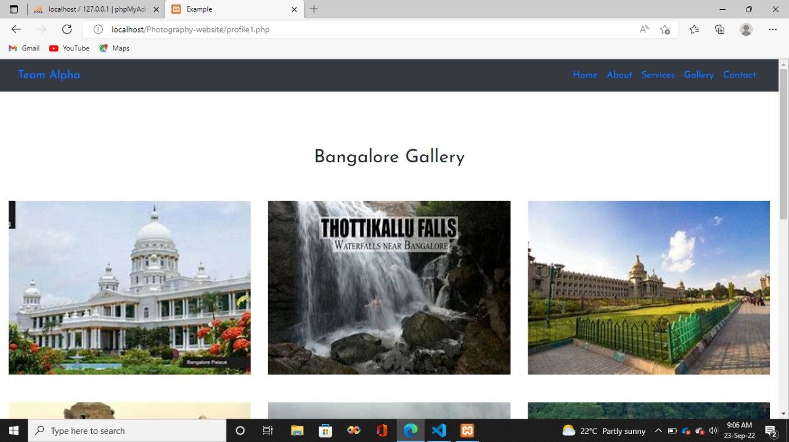

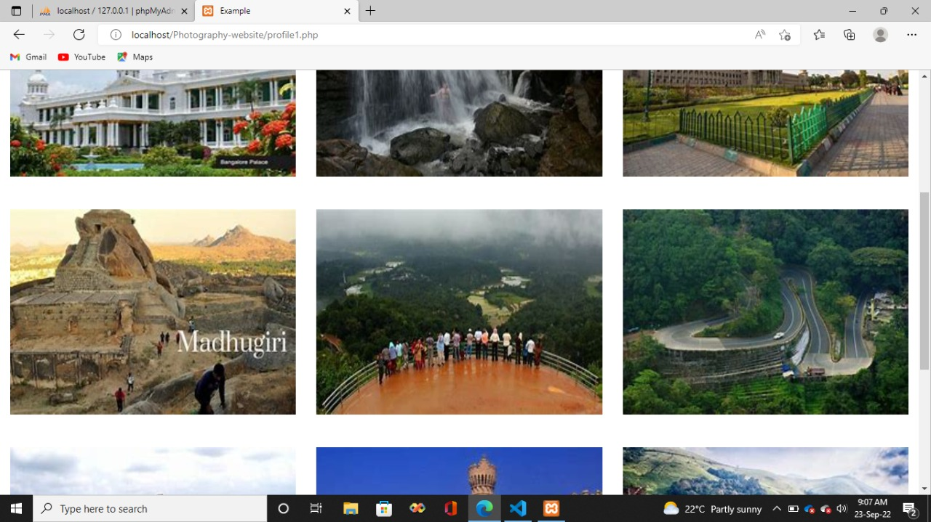

8.4.2 Telangana Gallery

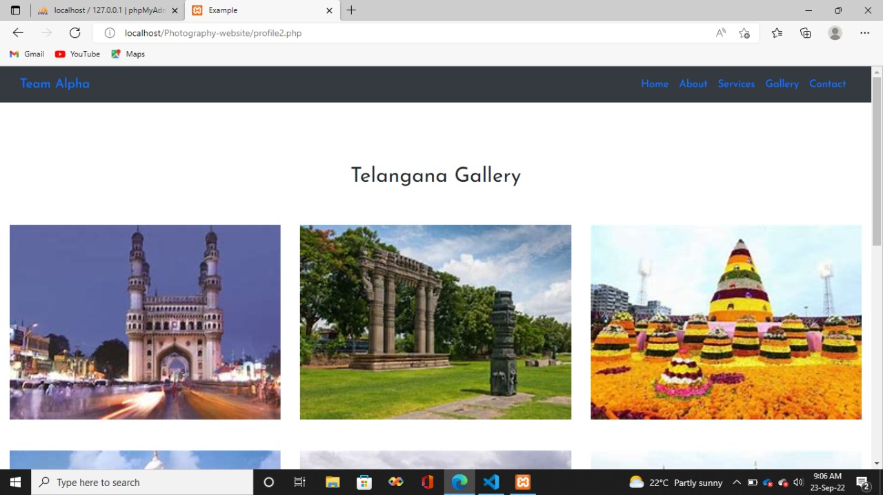

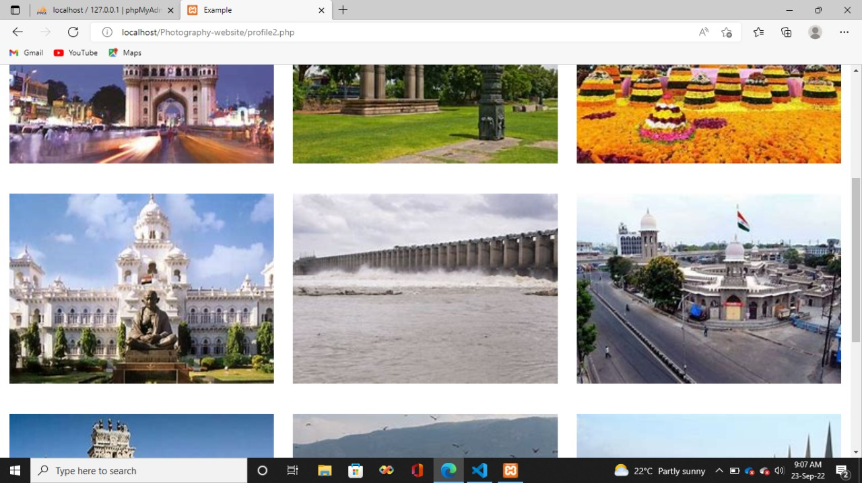

8.4.3 Delhi Gallery

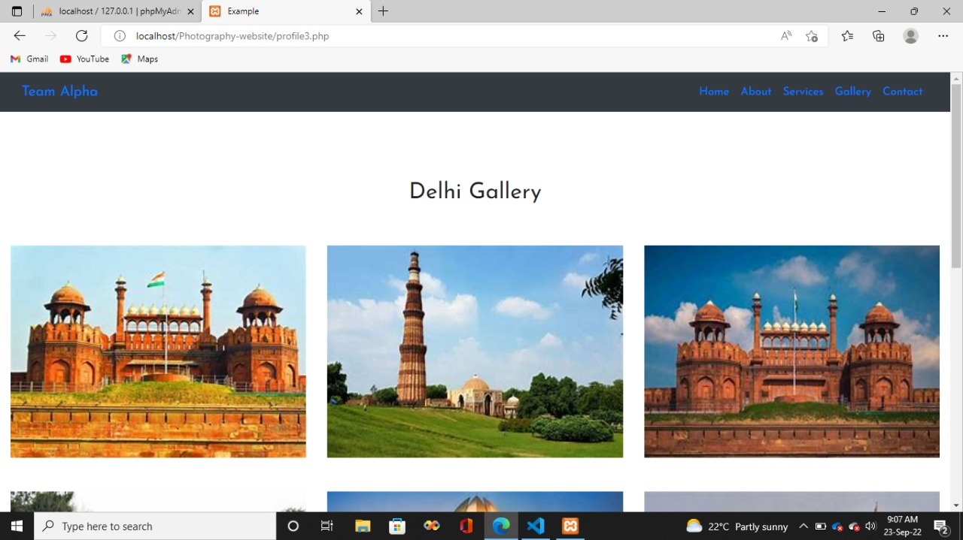

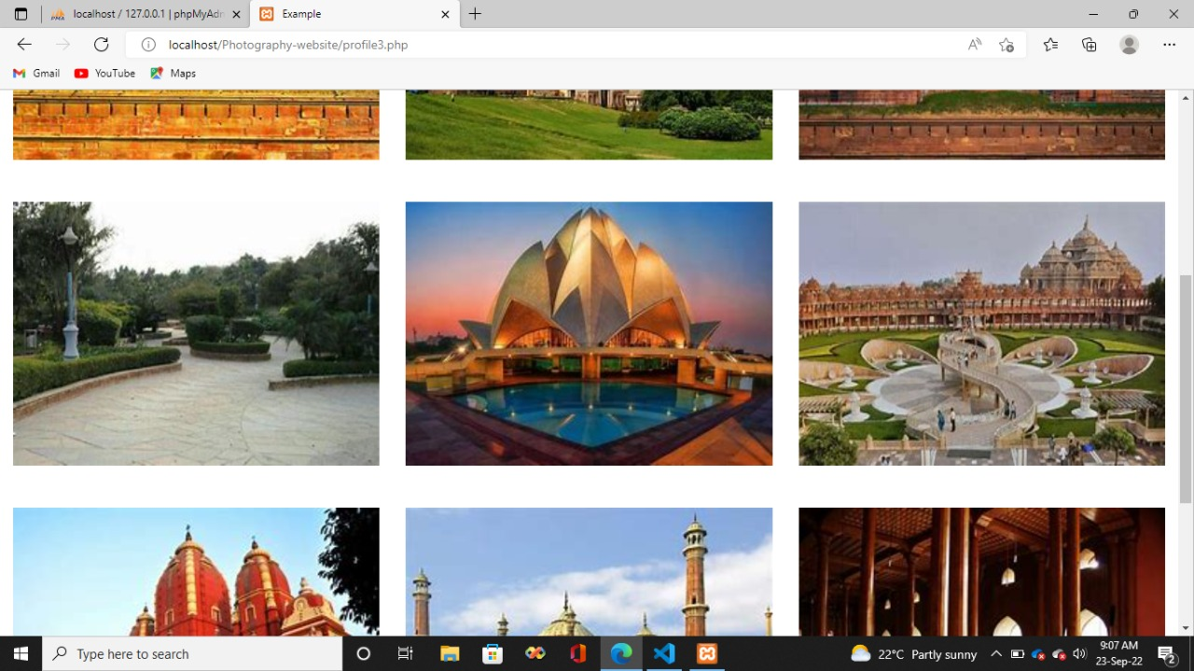

8.4.3 Delhi Gallery
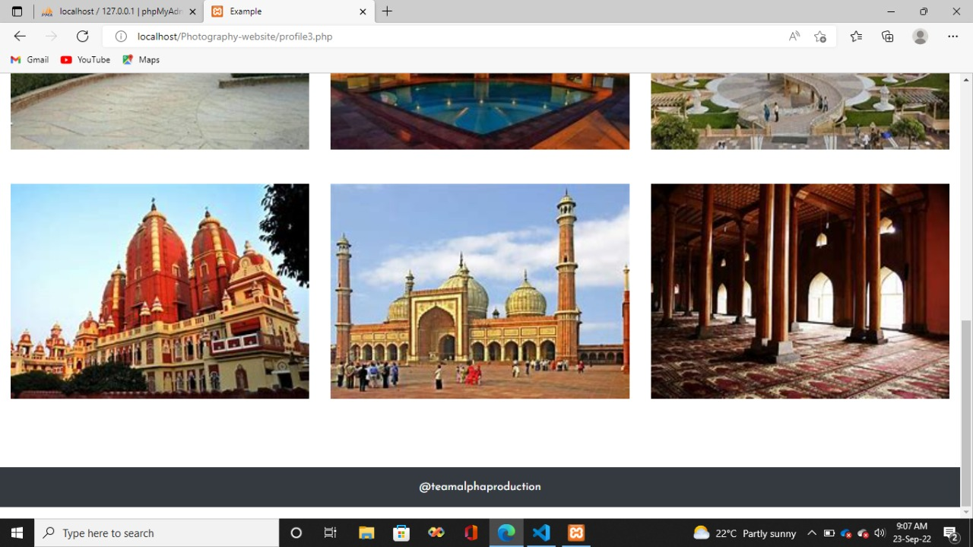

8.5 Contact Us
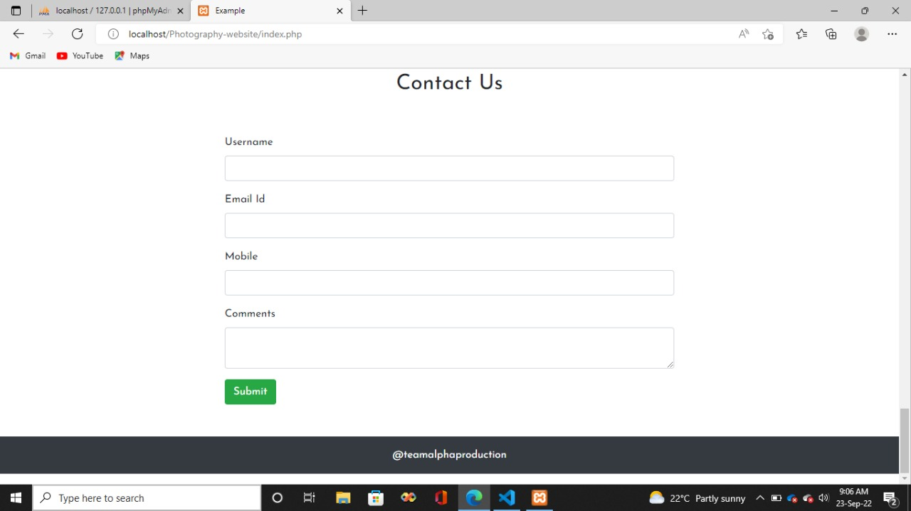
8.5.1 Contact Page

CHAPTER 9 CONCLUSION

The package was designed in such a way that future modifications can be done easily. The following conclusions can be deduced from the development of the project:

- Automation of the entire system improves the efficiency

- It provides a friendly graphical user interface which proves to be better when compared to the existing system.

- It gives appropriate access to the authorized users depending on their permissions.

- It effectively overcomes the delay in communications.

- Updating of information becomes so easier

- System security, data security and reliability are the striking features.

- The System has adequate scope for modification in future if it is necessary.

8.REFERENCE

- https://www.educba.com/php-references/

- https://www.mysqltutorial.org/

- https://www.w3schools.com/bootstrap4/bootstrap_ref_js_carousel.asp

- https://mzl.la/3pHQl2D

- https://bit.ly/3vbVbpY

- https://www.w3schools.com/bootstrap4/bootstrap_get_started.asp

